Installation instructions for Hohner HSB-10000-S

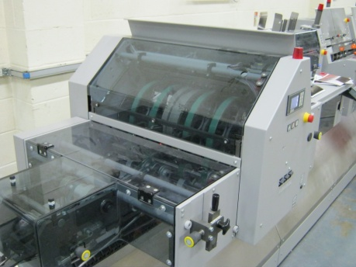
Female holder with 4 width crease channels
Matrix holding clamps
3 colour coded crease inserts for stocks from 85-350 gsm

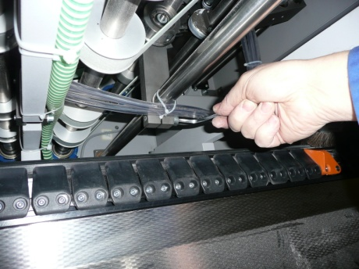
Loosen the creasing arm by using a 8mm hexagon key.
Gently pull away from creasing drum

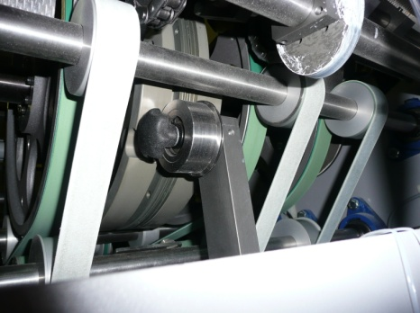
Unscrew black knob on the creasing arm
Pull off the original creasing unit and the washer

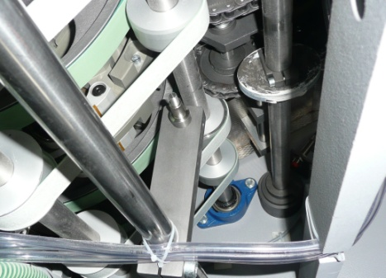
The crease unit stud with the original creasing unit removed

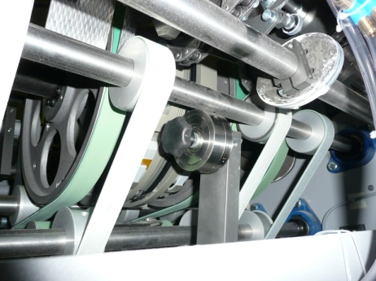
Slide on the new Technifold creasing female
Replace the washer and screw the black knob tightly

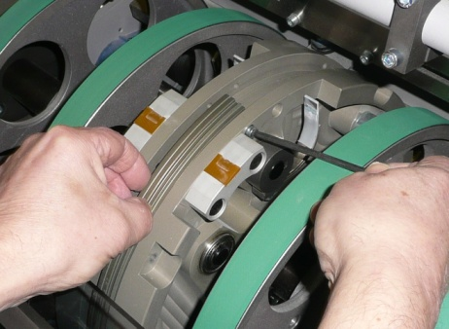
Ensure the removable creasing drum component is situated in the correct position as shown

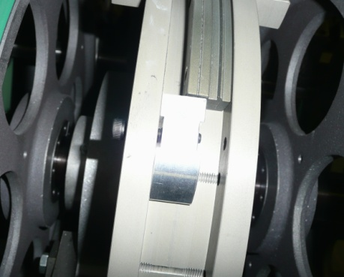

Push the 5mm black bolt through the drum and matrix holding clamp.

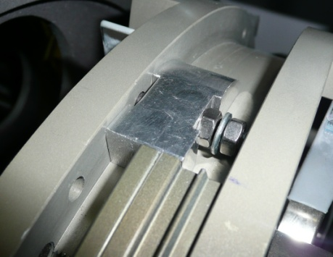
Attach the 2 x nuts and 1 x washer to the 5mm bolt at the same time
Tighten the nut nearest to the holder making sure the nut is flat & level with the matrix holder

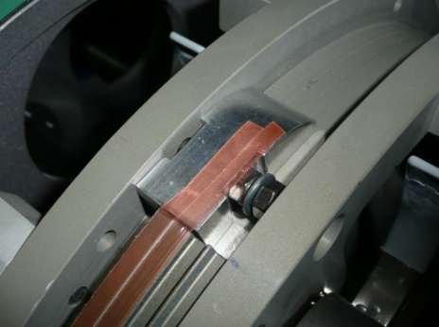
Apply 2 x strips of the red 2 x sided adhesive tape on either side of the V recess as shown
Covering the recess with the adhesive strips will make cleaning more difficult

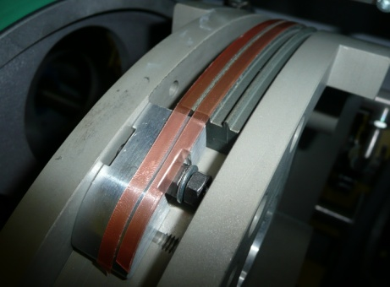
Rotate the drum slowly until the end of the crease drum becomes visible
Cut the red tape as shown

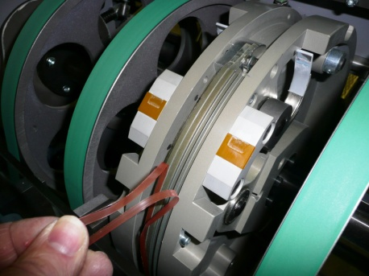
Rotate the drum and peel off the red plastic backing tape to reveal the expose adhesive

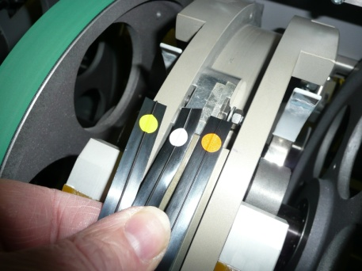
Select the correct crease matrix
Orange dot 100-135gsm
White dot 135-250gsm
Yellow dot 250-350gsm

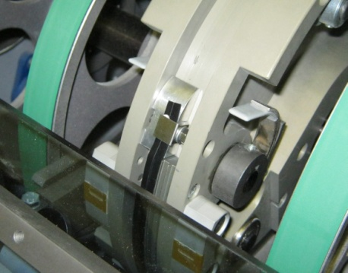
Push the crease matrix under the clamping bracket
Push the bracket firmly down and tighten the nut using a 8mm spanner

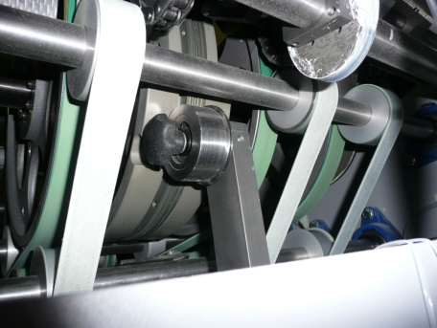
Slightly stretch the matrix as it rotates around the drum
Clamp the bracket firmly to the matrix and tighten with the 8mm spanner
Trim off any excess crease matrix

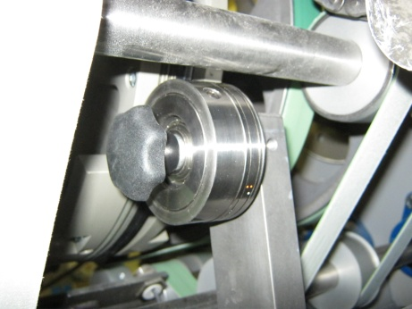
Push the female creasing arm back onto the drum
Position the female nearest to the creasing arm into the centre of the black creasing matrix

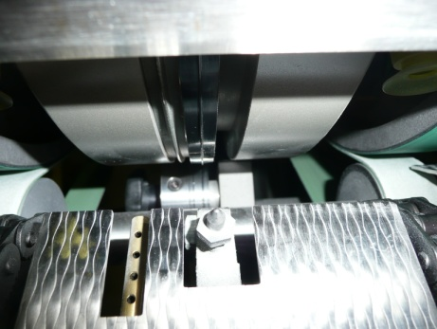
To align the female in to the centre of the black matrix view the parts from the top of the cover feeder

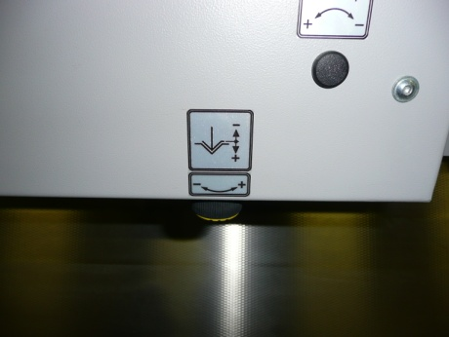
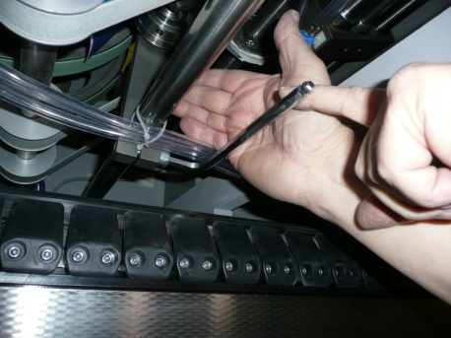
Adjust the crease depth by turning the knob
Move the creasing arm into position and tighten using a 8mm hexagon key

